On-line Fast Food Store

**Name of the website and project description**

***Swiftyfood*** is an online food store where user can order from the available food items from the menu. Additionally there are features for the user to search the menu for the food items that he wants to order. The User can filter the food items based on the vegetarian or non-vegetarian, type of food item like Main course, dessert or drinks, or categories like burger, pasta or pizza, etc.

The user registers into the system by providing his information and logs into the system with his credentials. After logging in user selects the items that he wants with or without the help of the search and search filter. The cart stores all the items that the user adds to his order.

Once the user finishes his order, he can checkout the same and pay through the pay option on the top left hand side of the screen and after the payment the order is saved into his history. The user history is available anytime to the user after he logs in and clicks on my history.

The employee of the company can login using his credentials and add/delete/modify items of the database.

**Database Design**

create database swiftyfood;

use swiftyfood;

CREATE TABLE userCredentials(userId INT auto_increment, userName varchar(15), password varchar(10), PRIMARY KEY (userId))AUTO_INCREMENT=2000;

CREATE TABLE empDetails(empId INT auto_increment, empUserName varchar(15), password varchar(8), PRIMARY KEY (empId))AUTO_INCREMENT=5000;

CREATE TABLE userDetails(userId INT, userName varchar(15), emailId varchar(20),mobileNo varchar(10), aptNoName VARCHAR(30), place varchar(15), zipCode varchar(10), FOREIGN KEY (userId) REFERENCES userCredentials(userId), PRIMARY KEY (userId));

CREATE TABLE orderDetails(userId INT, orderNo INT auto_increment, orderDateTime DateTime, total decimal(4,2), tax decimal(4,2), totalPrice decimal(4,2), PRIMARY KEY (orderNo), FOREIGN KEY (userId) REFERENCES userCredentials(userId))AUTO_INCREMENT=1000;

CREATE TABLE itemDetails(itemNo INT auto_increment, name varchar(30), type varchar(15), nvOrVeg INT(1), description varchar(50), imgPath varchar(30), rate decimal(4,2), delFlag INT, PRIMARY KEY (itemNo))AUTO_INCREMENT=500;

CREATE TABLE orderedItemDetails(orderDetailsId INT auto_increment, orderNo INT, itemNo INT, quantity INT, FOREIGN KEY (orderNo) REFERENCES orderDetails(orderNo), FOREIGN KEY (itemNo) REFERENCES itemDetails(itemNo), PRIMARY KEY(orderDetailsId,orderNo))AUTO_INCREMENT=101;

***Sample***

insert into itemDetails(name,type,nvOrVeg,description,imgPath,rate,delFlag) values("Chicken Burger","Main", 2, "Chicken, patty, lettuce, crispy flakes, mexican sauce", "/images/Chicken burger.jpg", 5.00, 0 );

**Languages and framework used**

**Client side:** HTML, CSS, Boostrap CSS, JavaScript, JQuery, Ajax

**Server side:** PHP (LAMP, MAMP)

**Database:** MySQL

**Work Division**

**Karthika:**

Main Files :(home.html, history.html, history.js, history.php, view.html, view.php, itemsFetch.js, print.php, design.css):

* List available food items in the system. User will be able to filter the results based on at least one criterion (i.e. category). Also, should be able to “Search” for a specific item.
* Add item(s) to the cart and checkout. For the on-line shopping sites, pricing will be included but payment functionality doesn’t need to be implemented. However, you will keep track of inventory. For websites where a shopping cart does not exist, you can implement Wish list or Favorites and save those listings.
* Show the history of purchases or saved lists for the user.

**Aneri:**

Main Files: (displayMenu.php, updateItem.php, updateMenu.php, upload1.html)

* For Admin user(s):
  + List all items
  + Add new item
  + Delete item
  + Update item

**Madhav:**

Main Files: Main files ( validation.js, userpage.html, insert.php, validate.php)

* User signup: Register a new user to the system.
* Check the new username or email address if it’s already registered to the system using AJAX.
* Form validation: Check if all mandatory fields are filled out. (JQuery)
* Check if password is strong enough. Define the rules of having a strong password. (JQuery)
* User login

**Screenshots for main functionalities**

Home

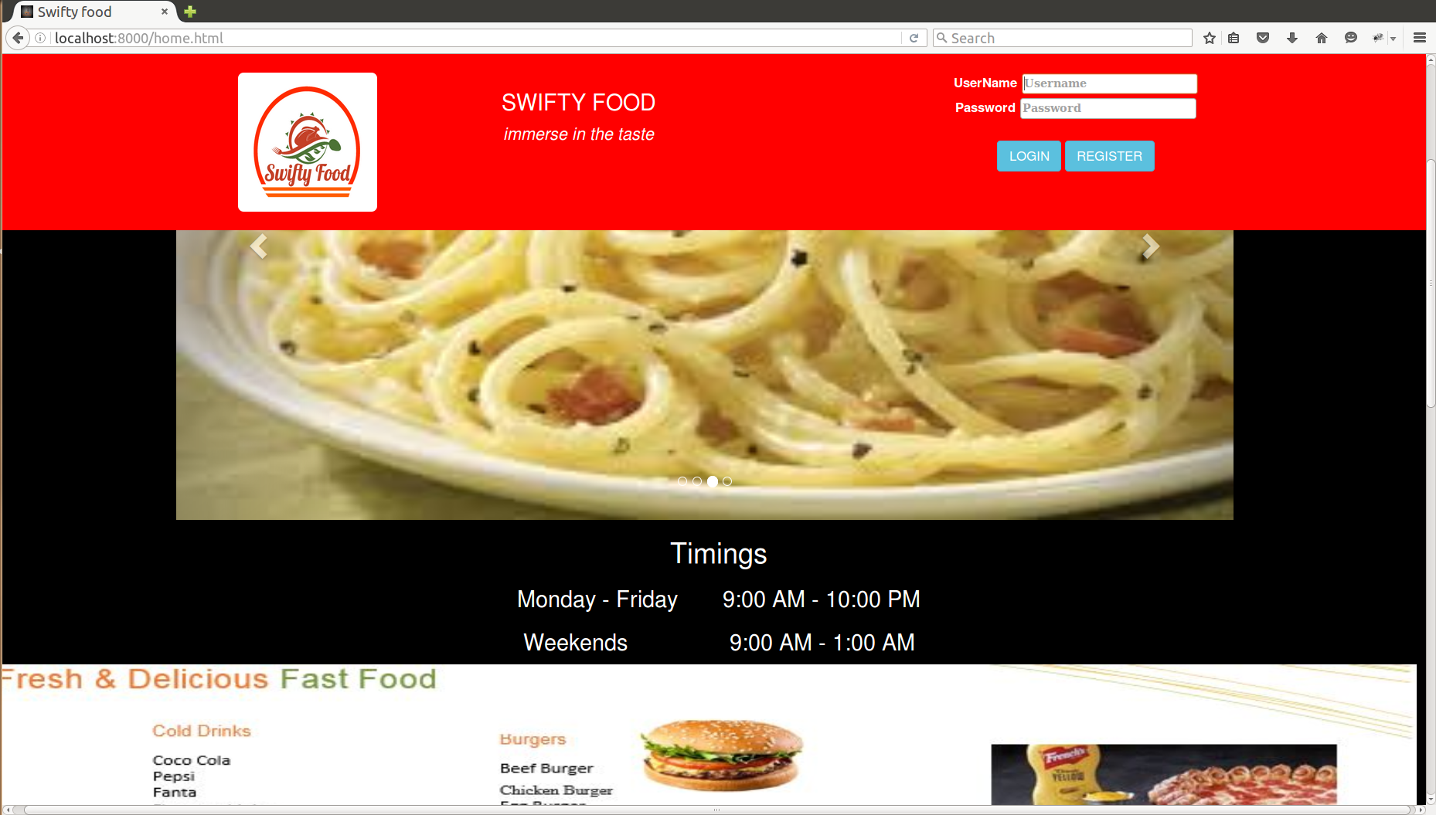

Home contact details

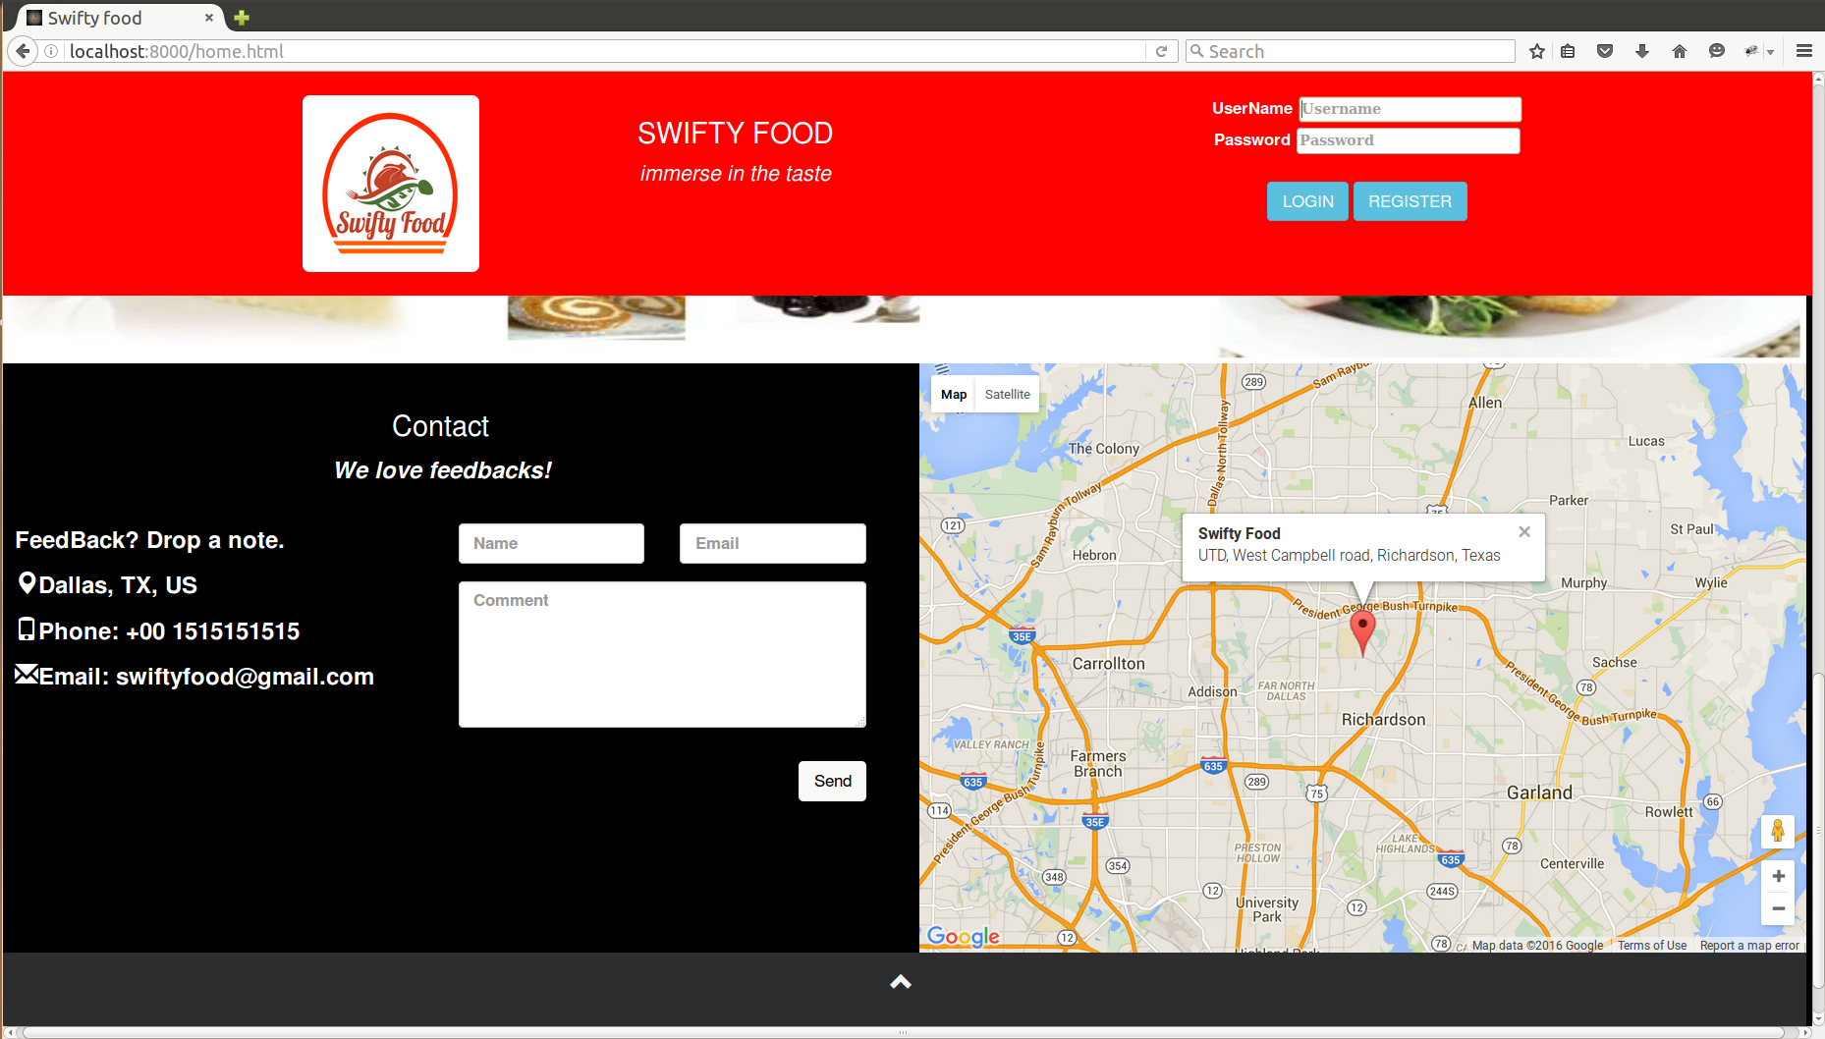

Password rule and username availability

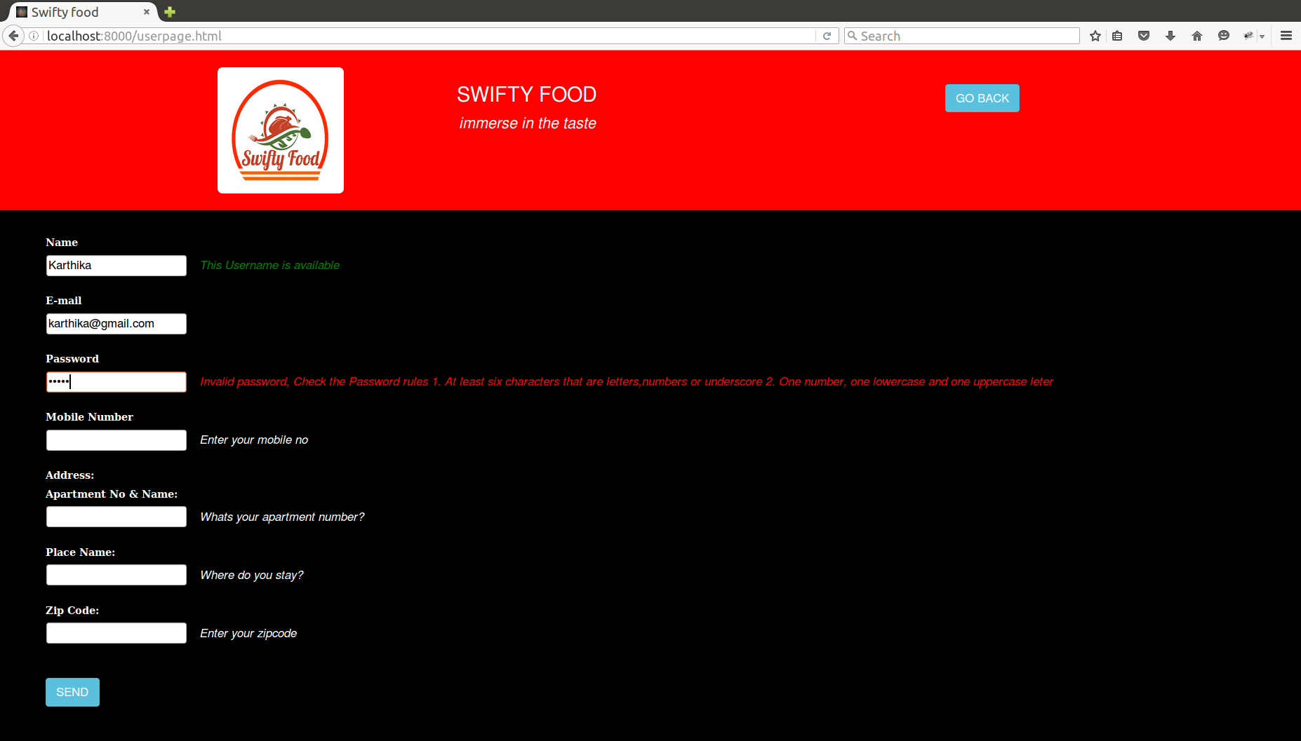

Validated password

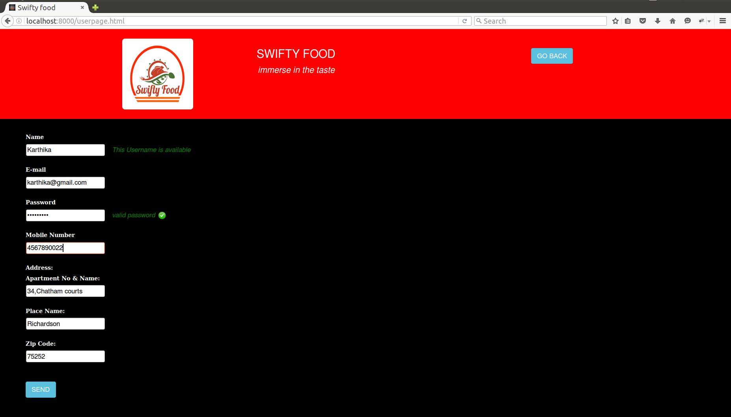

Invalid credentials

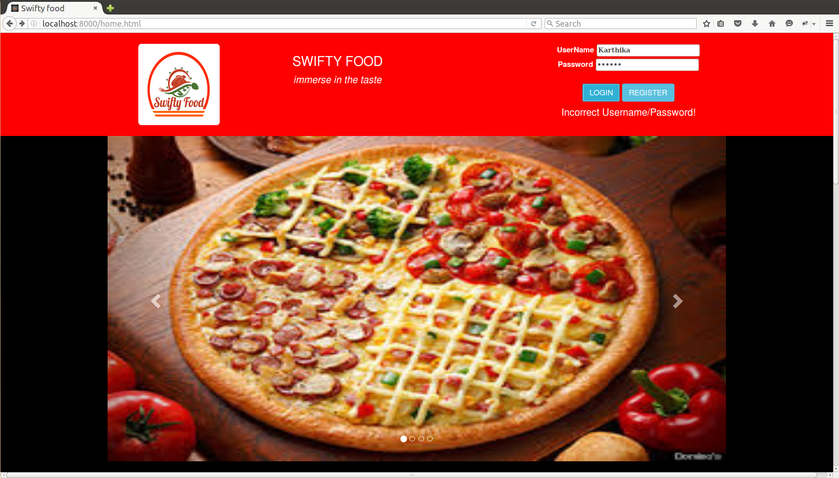

View items

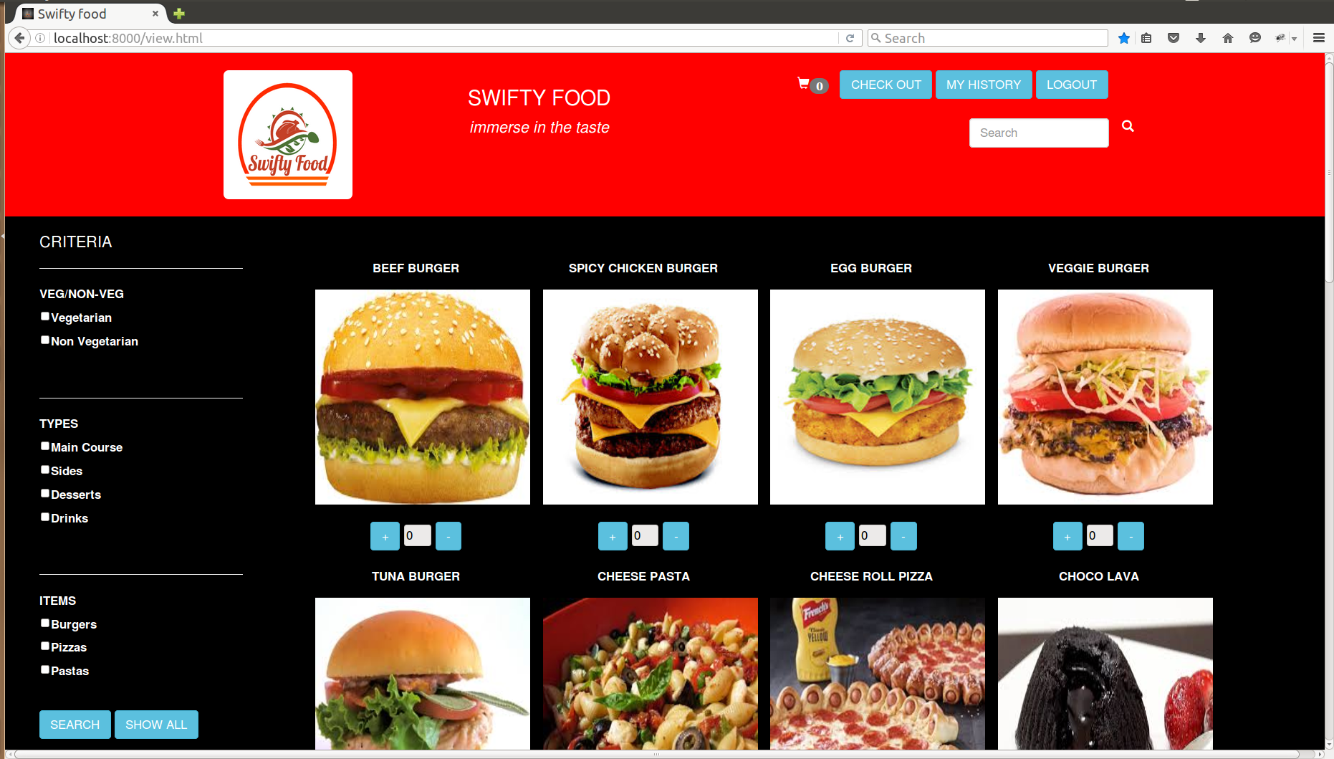

Search

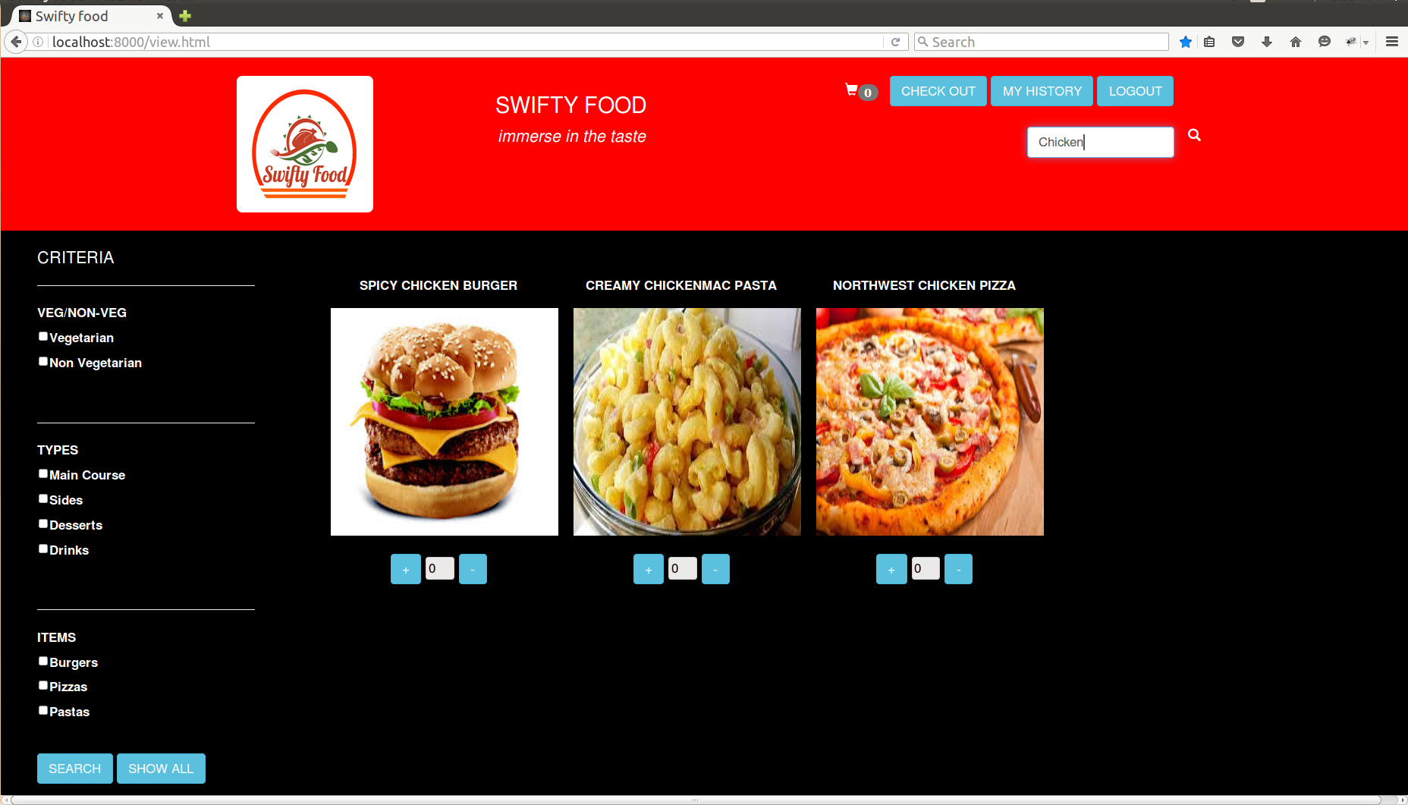

Filter

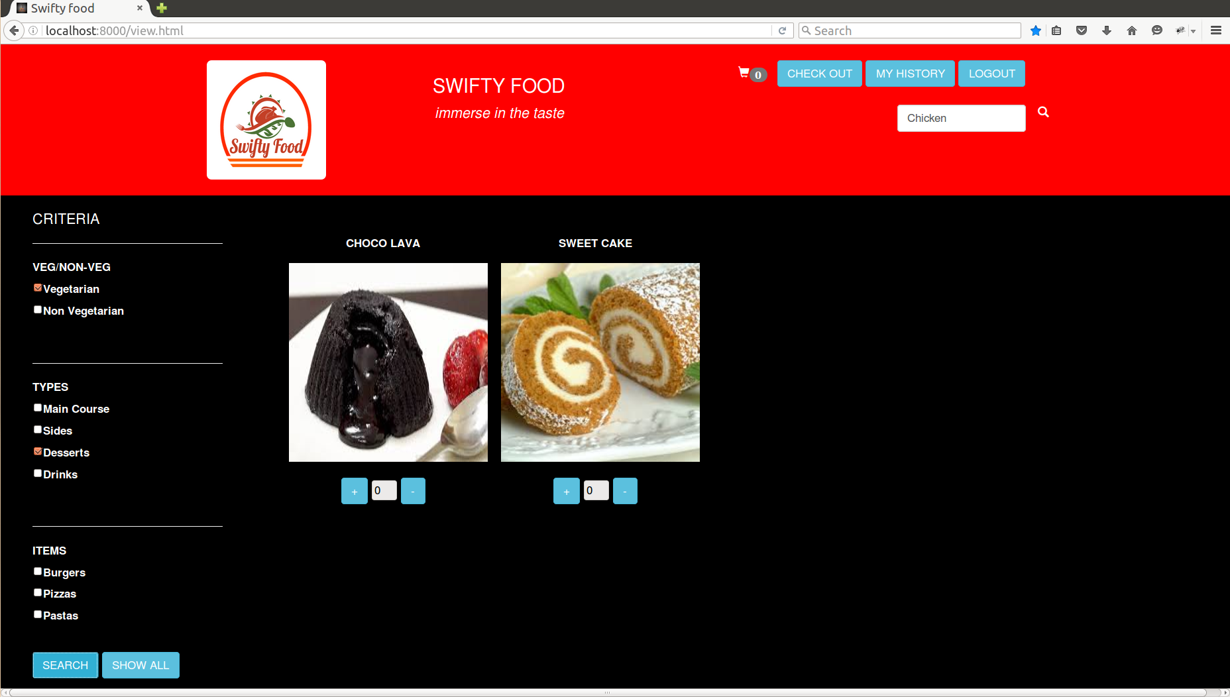

Items selected and cart updated

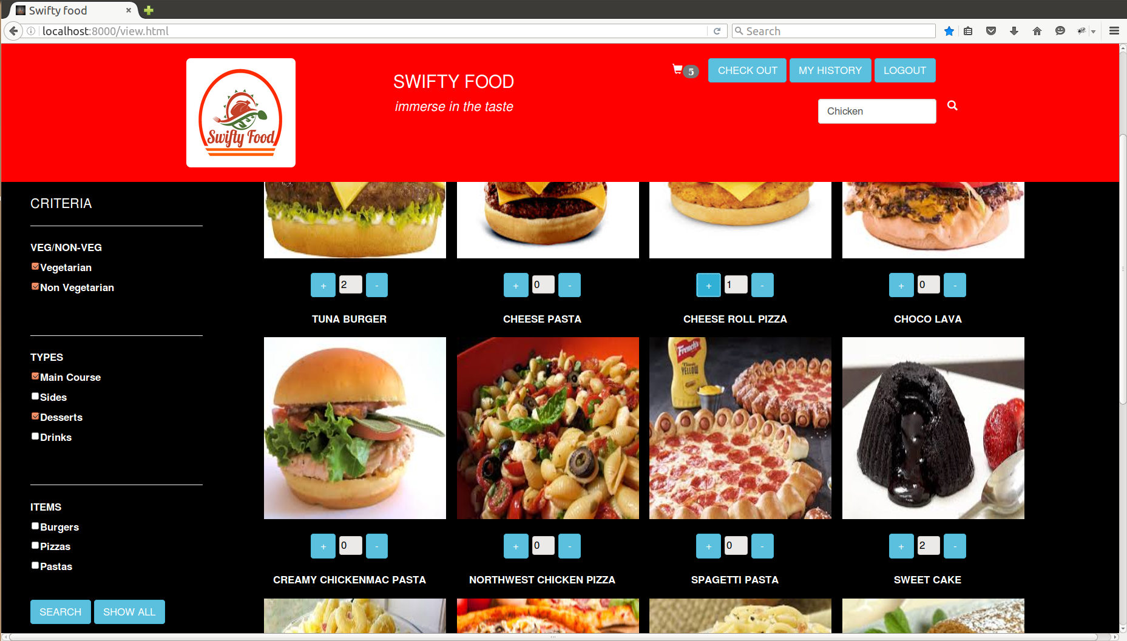

Cart

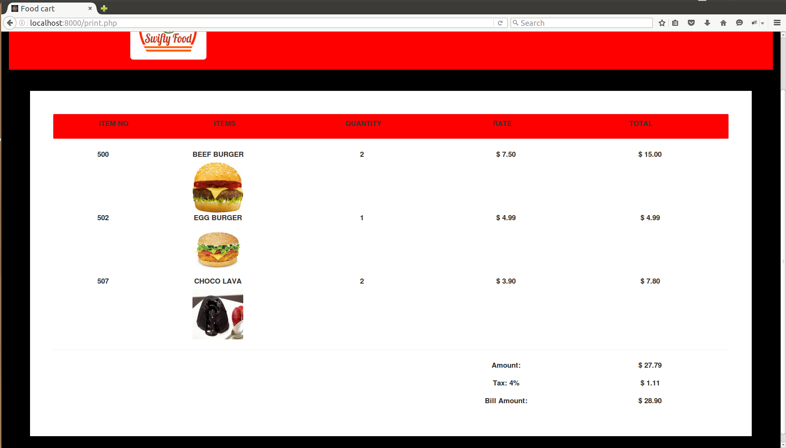

Payment message

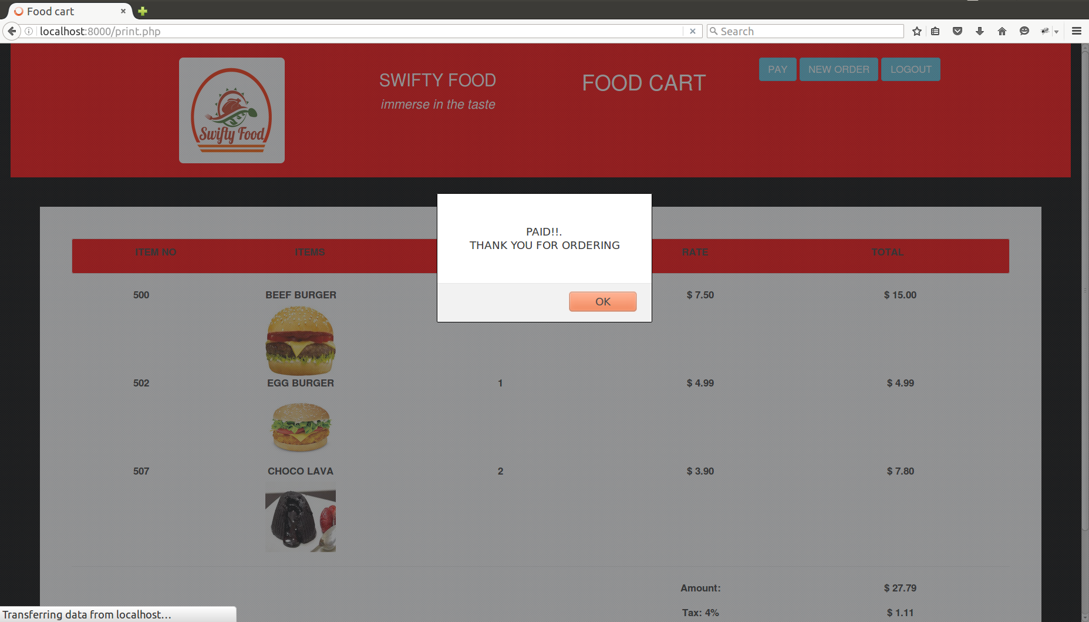

User history

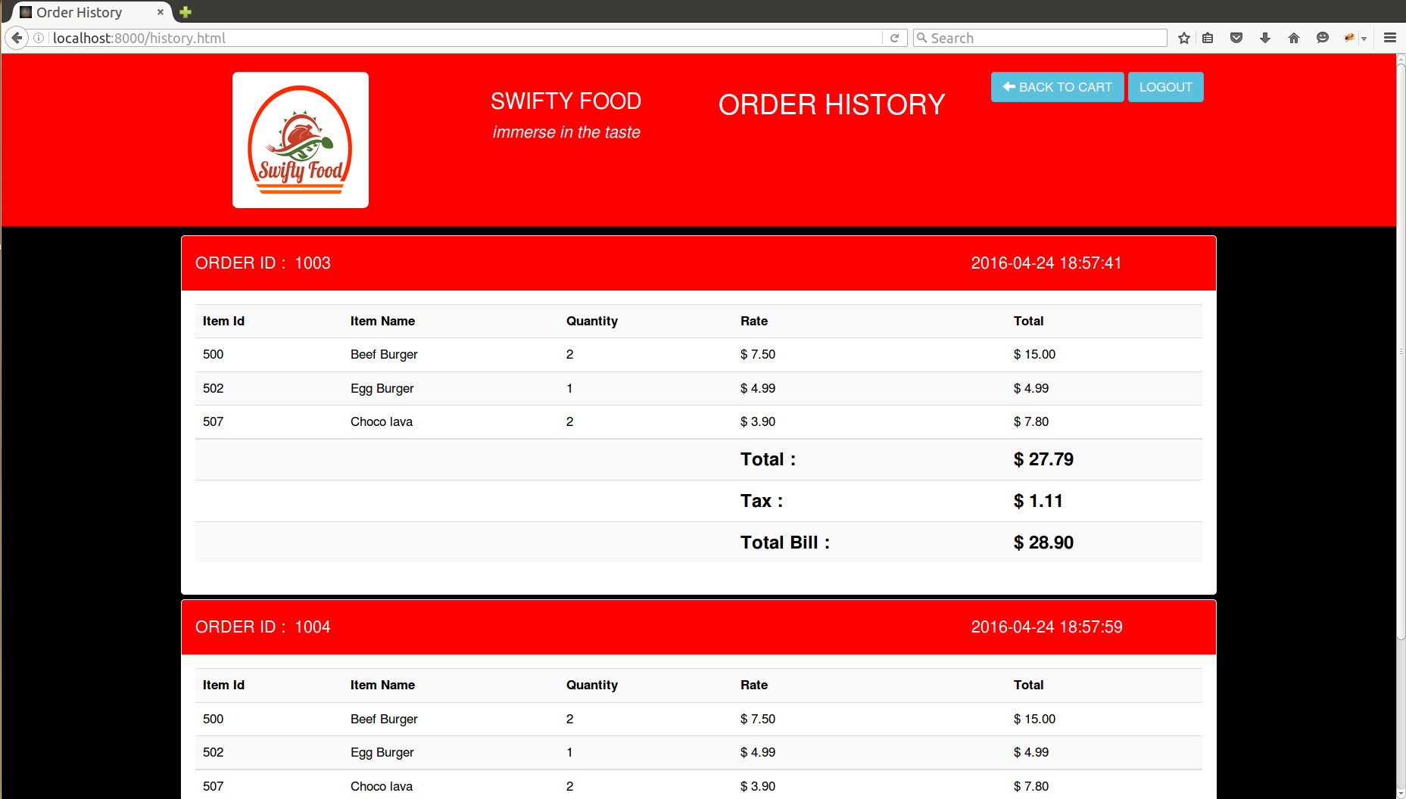

Employee view item

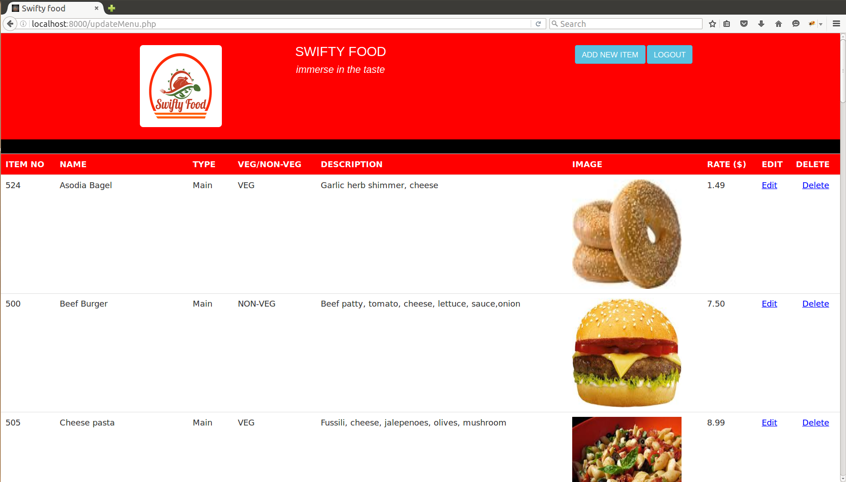

Add item

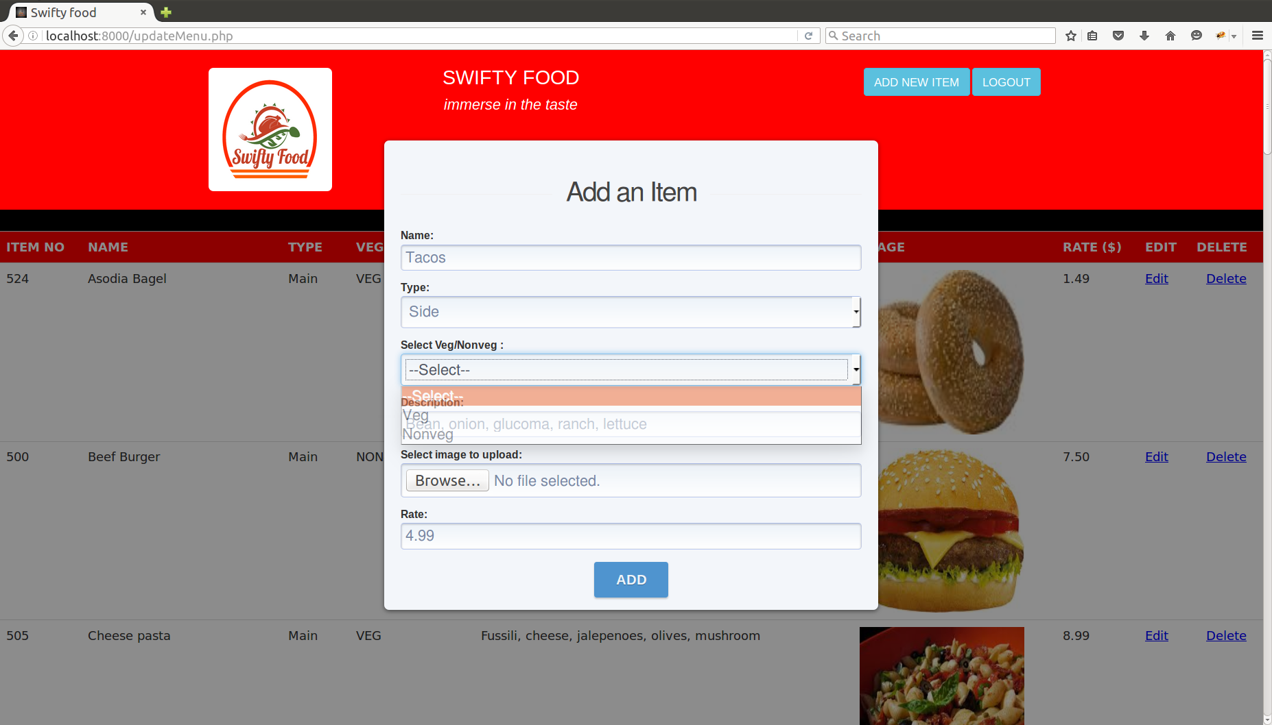

Update

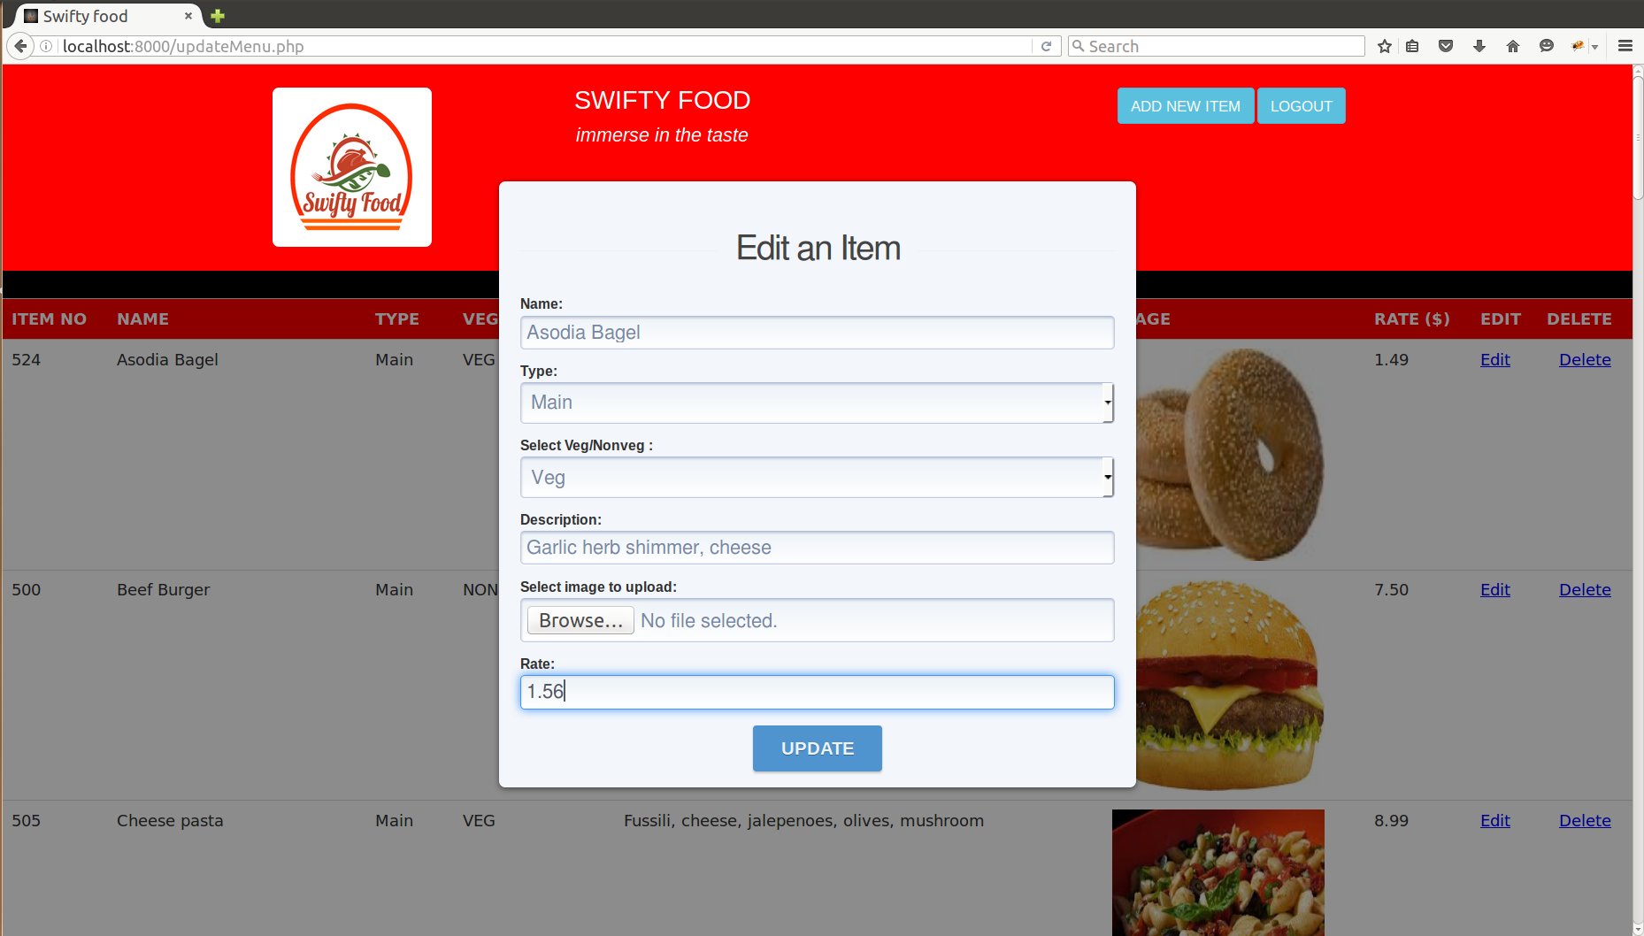

Delete

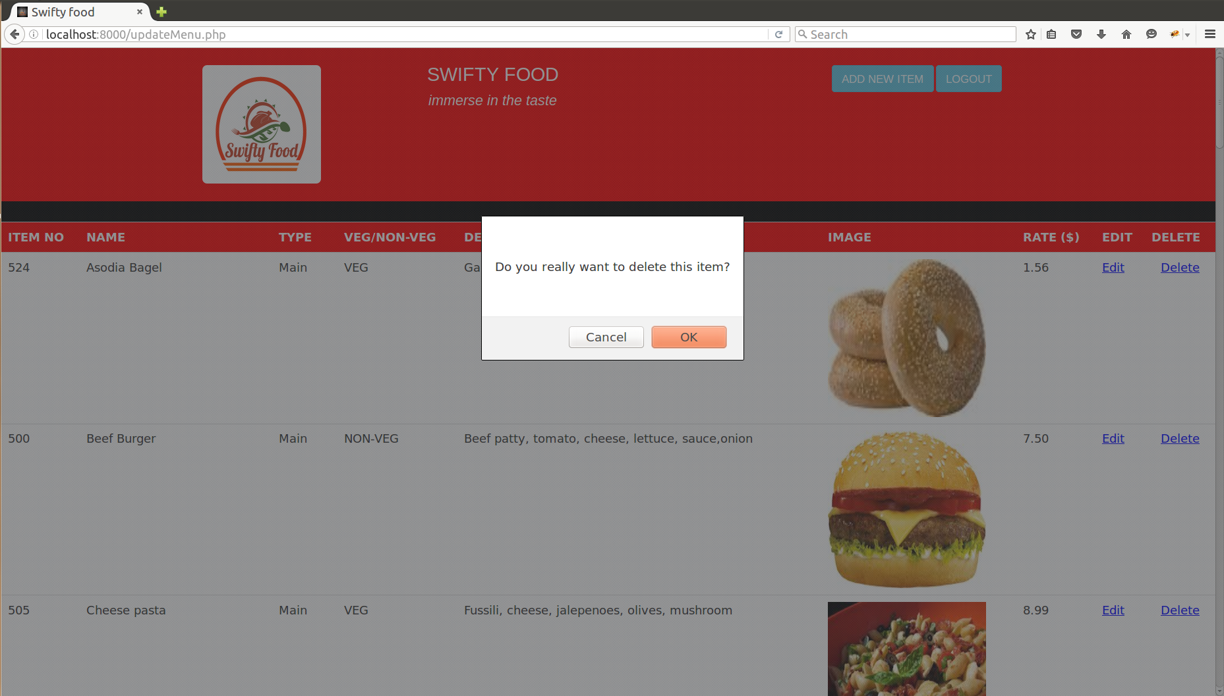

**Team Members:**

Karthika Karunakaran - Kxk152430

Aneri Shah - Aps140630

Madhav Mohan - Mxm158830

**Comments/Additional information:**

The items from the itemDetails table are not deleted from the database on deletion of the item, rather a deletion flag is set to “1” (initially all the items deletion flag are set to “0”).

This way the database consistency is maintained even after deletion of the item, the user history can still point to that deleted item. Cascaded delete does not make sense for the user history.